`

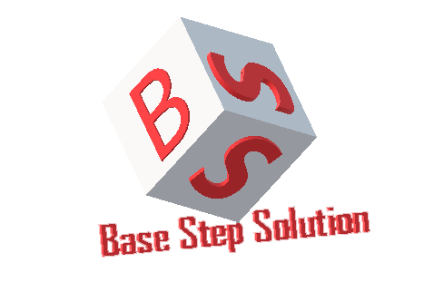

Meeting Minutes

Van Lang Admissions

# Revision Table

|  |  |  |  |
| --- | --- | --- | --- |
| Author | Date | Reason for changes | Version |
| Khoi Nguyen | 12/01/2017 | Initial Document | 1.0 |

Table of Contents

Revision Table 1

I. Purpose 3

II. Participant in meeting 3

III. Content of meeting 3

IV. To do task 4

|  |  |  |  |  |  |
| --- | --- | --- | --- | --- | --- |
| **Writer:** | Khởi Nguyễn | **Location:** | Room 701C | | |
| **Date:** | 12/1/2016 | **Start:** | 9h – 10h +  14h – 15h |  |  |

# Purpose

* Review List of Usecase

# participant in meeting

Customer : Lecturer Nguyễn Thế Quang

Team Capston:

* Nguyễn Thái Hiền
* Nguyễn Hoàng Anh Tài
* Đoàn Anh Minh
* Trần Xuân Hải
* Nguyễn Anh Khởi
* Nguyễn Xuân Thái Hiền

# Content of meeting

* Content of news : Can insert clips into it? Actor is youtube?
* Have button share
* Have Elastic search server , Redis server , System server : 3 system
* Related news ?
* Divide the categories into multiple levels?
* Have Deactive News & Active News functions
* Focus on FAQ function: Question Content, Email, Name.
* When viewing the account list, show the basic information of the account (Statistical functions of productivity, efficiency of working people: to the next version)
* Edit information account : Can the system admin edit acount information?
* Sync data from MongoDB to Redis & Elastic Search.

# To do task

* Update Documents

---- *** ----